Wireshark Home Tasks

Request Packet:

- Frame Header
The frame header sends the data frame exactly to the destination network, it gives the confirmation that the data frame is going to the correct destination.
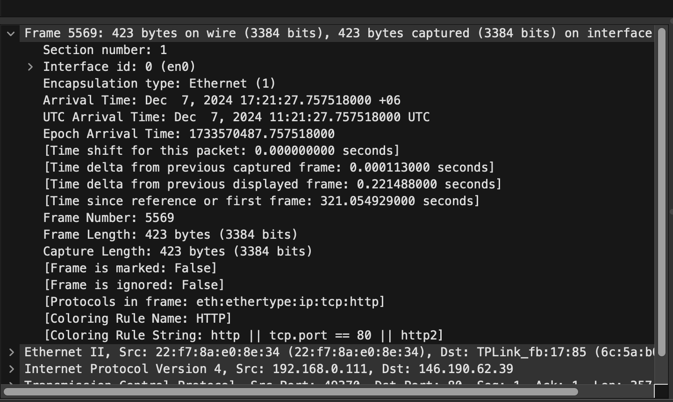

- Ethernet Header
Ethernet header contains the source and destination MAC addresses. It also shows the the data type i.e. IPv4. In the end it contains checksum part as well
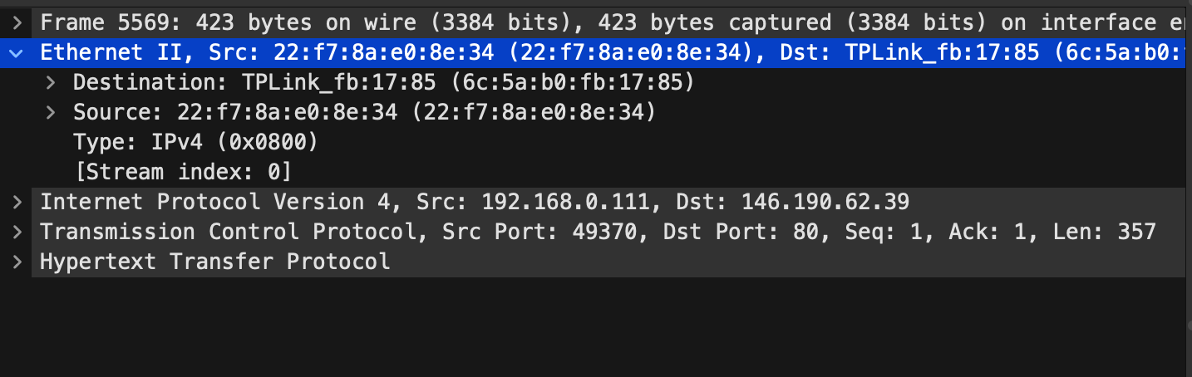

- Internet Protocol Header
In a network for routing and sending packets from sender to receiver this header plays an important role. This header keeps track of source and destination IP addresses and the total length of data also the time to live for the session.
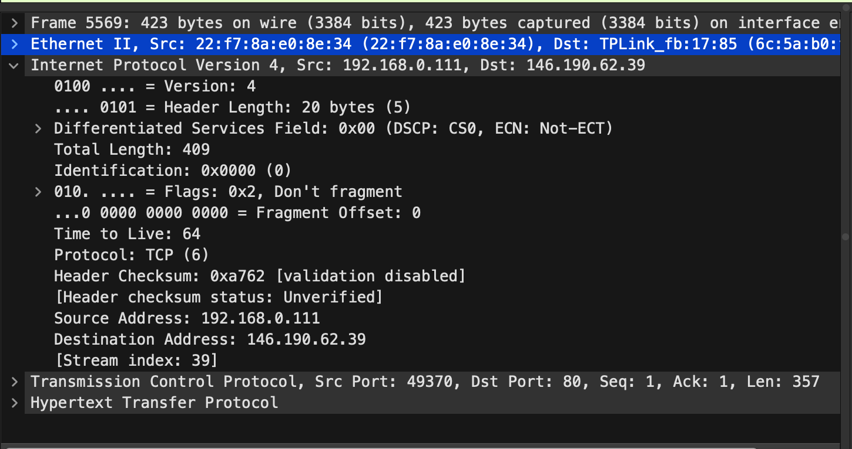

- Transmission control protocol Header
It contains source and destination port number, window size, sending data sequence and acknowledgement number for the current data. It also shows the urgent pointer.
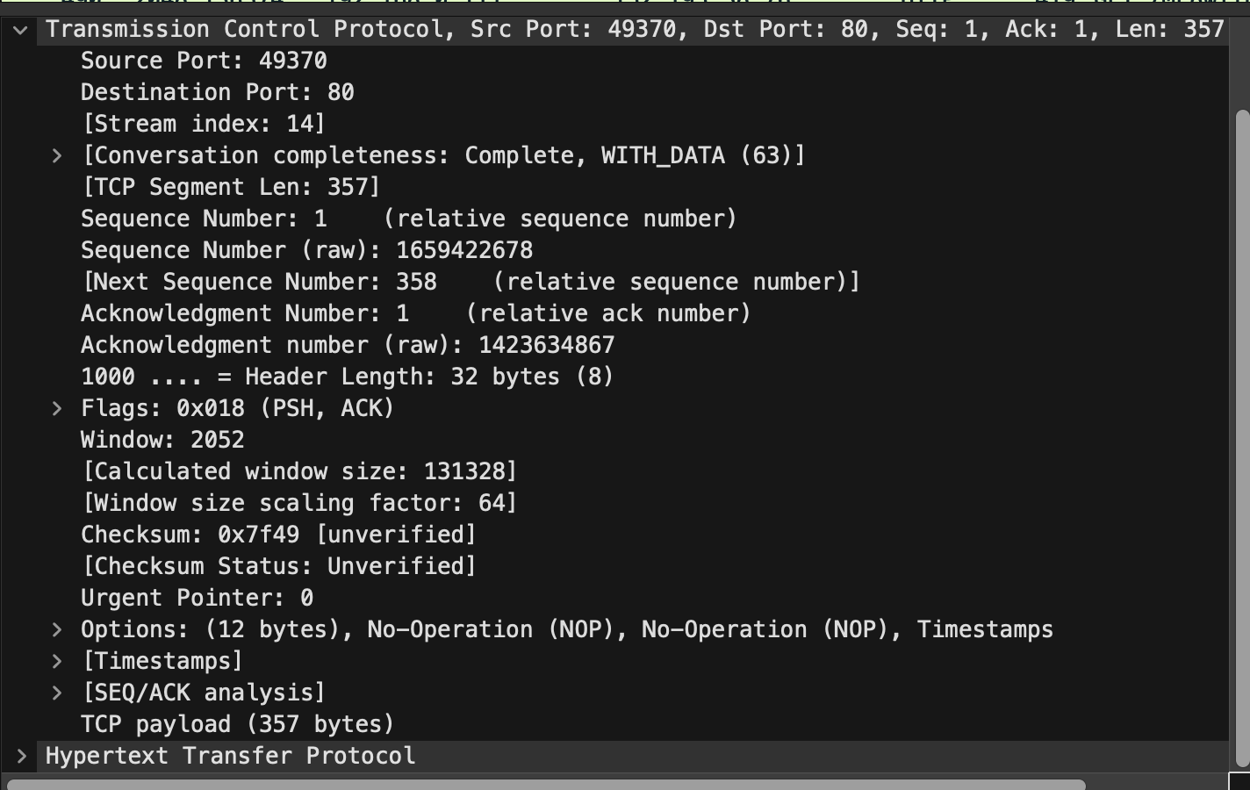

- Hypertext Transfer Protocol header
It shows the request type i.e. GET, the current hosting web address also the connection type.
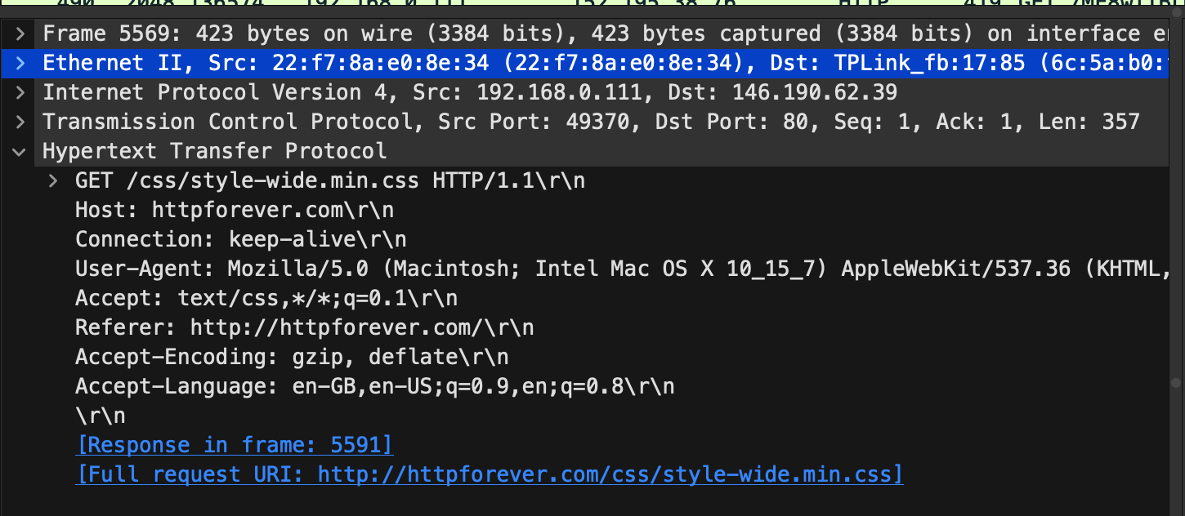

Response Packet:

- Frame Header
This header notifies whether the captured packet is responding to the previous packet or not. It contains frame number and frame length.
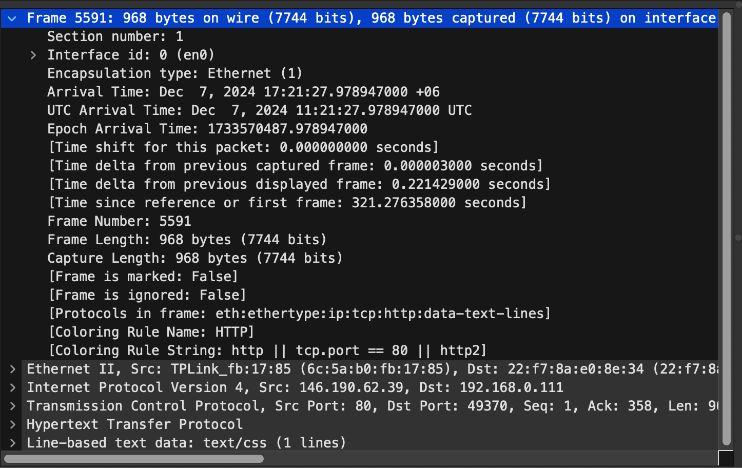

- Ethernet Header
As like a request packet ethernet header it also contains Mac addresses of the source and destination.
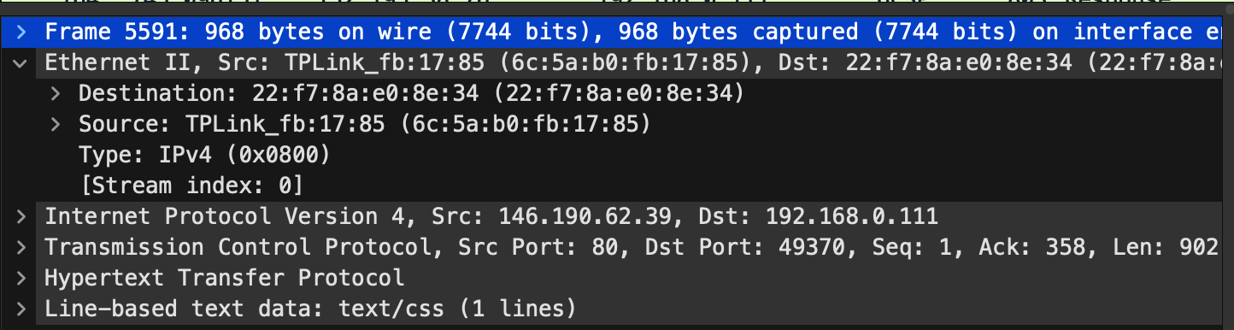

- Internet Protocol Header
Containing source and destination IP addresses this ensures that accurate delivery of packets
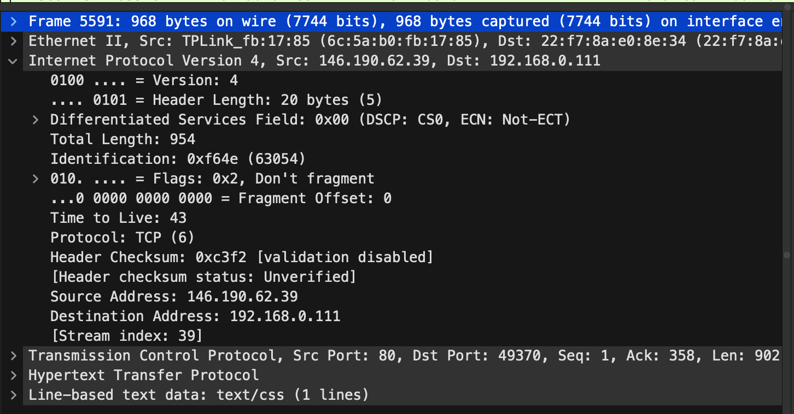

- Transmission control protocol Header
This header ensures the proper data transmission of packets, also contains source and destination port number and sequence & acknowledgement number to check whether the data is acknowledged or not
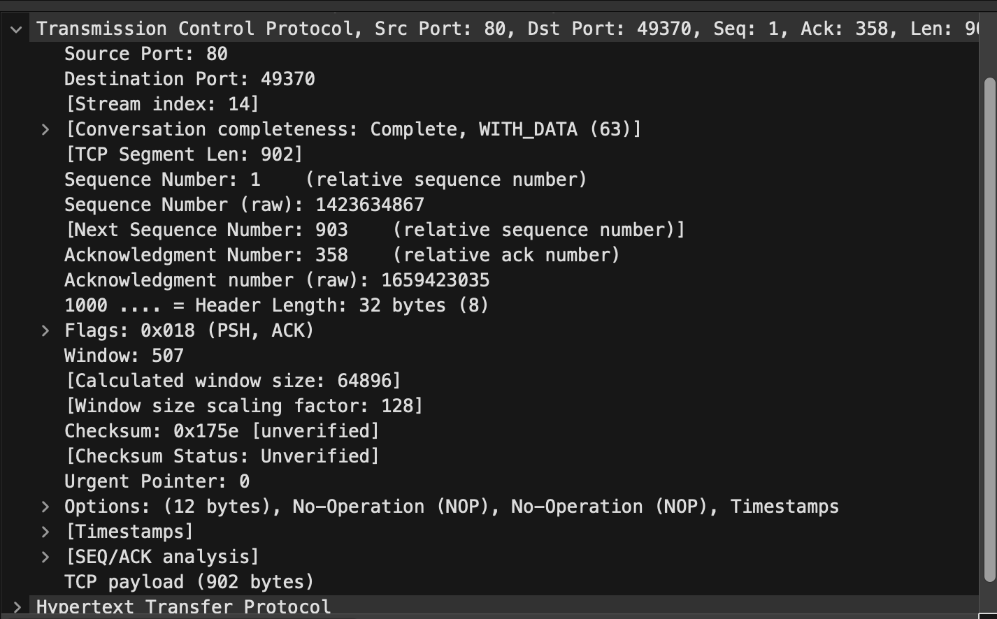

- Hypertext Transfer Protocol header
This header sends the response whether the request was successful or not. Mainly it communicates with the sender requesting it. It contains the status code, response line, and request body which were sent.
